Marking Guide

Question 1

(a) N₂O₄ 2NO₂ [2]
Initial concentration=0.625 mol/dm³
Equilibrium concentration=0.625-0.075 =0.55*2
N₂O₄ 2NO₂
O.O75mol/dm³ 1.10 mol/dm³ [3]
(b) K_{C}= [NO₂] [1]
[N₂O₄]
K_{C}=(1.10)²
0.075
K_{C}=1.21
0.075
K_{C}=16.13mol/dm³ [2]
(c)K_{c} for the backward reaction, find the reciprocal of the forward reaction 1/16.13 =0.062mol/dm³
(d)calculate the Kp for the reaction
Kp=K_{c}(RT)^{n} [2]
Kp=16.13 ×8.31 ×300
=40212.09 J/dm³
Question 2
(a) liquids have a fixed volume
-liquids have no fixed shape
-liquids are non- compressible [3]
(b) when the liquid molecules gain energy they become mobile as a result they are able to overcome the attractive forces and they are lost. [3]
(c)(i)mercury, water, benzene [3]
(ii)mercury will have the highest boiling point. This is because in mercury the amount of heat needed to break the forces of attraction is high [3]
(d)(i)the speed will be the same because the temperature is constant [1]
(ii)the rate of collision will increase because the volume has been increased [2]

ANSWERS TO QUESTION 3
(a) Number of electrons in outer shells
(b)(i)Readiness or ability of an atom to accept electrons.
(ii)(a) B
(b)-more electronegative
-more number of electrons in the outermost shells.
-bigger atom.
(c)(i)Group I have low melting and boiling points compared to group II
Group I are soft metals than group II
Group I are silvery and group II are white
(ii)- M₂CO₃
-NCO₃
(iii) M is more stable than N and they do not easily decompose on heating.
NCO₃→NO + CO₂ while M₂CO₃ does not decompose
(d)(i) is a reaction where a forward and backward reaction take place at the same time.

ANSWERS TO QUESTION 5
(a)(i) Al and S
(ii) Same number of shells
(b)(i) S
(ii)It increase the radius for an extra electron to have enough room for electron spin.
(c)(i) K⁻
(ii)It needs a lot of energy to release an extra electron from the third shell.
It has a stable structure like that of a noble gas.
(d)(i)24g of Mg→6×10²³ atoms
3g→x
X=7.5×10²²atoms
(ii)32g of O→6×10²³atoms
4g→x
X=7.5×10²²atoms
(iii)0.015×6×10²³=9×10²¹atoms
(e)(i)2 ions
(ii)27×2=54
32×3=96
16×12=192
342
=0.0096g

ANSWERS TO QUESTION 6
(a) An acid is an electron-pair acceptor.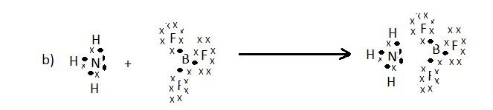

(c)C₆H₅COOH→C₆H₅COO⁻ + H⁺
[H⁺]=√K_{a}×[C₆H₅COOH]
[H⁺]=7.937×10⁻³mol/dm³ [3]
pH= -log[H⁺]
=2.1 [2]
(d) pOH= -log√K_{b}×[NH₃]
=-log√1.7×10⁻⁵×0.1
pOH=2.88
pH=14-pOH
14-2.88=11.12
(e)
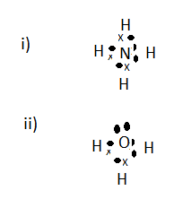

ANSWERS TO QUESTION 7
(a)(i)(1×2)+(-2×7)+2Cr=0
Cr=+6
(ii) (-1×3)×Sb=-3
Sb=0
(b) MnO₄⁻→MnO
N₂H₄→N₂
3H₂O+MnO₄⁻→MnO+6OH⁻
4OH⁻+ N₂H₄→N₂ +4H₂O
3H₂O+MnO₄⁻+5e⁻→MnO+6OH⁻ ×4
4OH⁻+N₂H₄→N₂+4H₂O+4e⁻ ×5
4MnO₄⁻+5N₂H₄→4MnO+5N₂+8H₂O+4OH⁻
(c)Cu +H⁺+NO₃⁻→Cu²⁺+2NO⁻₃+H₂O+ NO
Cu→Cu²⁺
NO⁻₃→NO
Cu→Cu²⁺
4H⁺+ NO⁻₃→NO+2H₂O
3Cu→3Cu²⁺+6e
6e+8H⁺+NO⁻₃→2NO+H₂O
3Cu+2NO⁻₃+8H⁺→3Cu²⁺+2NO+ H₂O
(d)
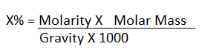

x/100=10.8×36.5/1.19×1000
x=33.1%

ANSWERS TO QUESTION 8
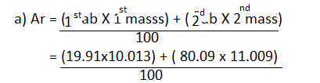
=10.811 of natural boron
(b)mass of C=1.33g of C,mass of H=0.22g of H,mass of oxygen=0.45g of O
C H O
1.33/12 0.22/1 0.45/16
C=4,H=7 and O=1
Empirical formula C₄H₇O
(c)mass of C=0.75g, mass of hydrogen=2.75-0.75=2.0g of H [2]
C H
0.75/12=0.0625/0.0625=1 2.0/1=2/0.0625=32 [1]
Empirical formula CH₃₂
Molecular formula=empirical formula × n n=molar mass/empirical=88/44=2

=(CH₃₂)_{n}
=(CH₃₂)₂
=C₂H₆₄
(d)(i) K⁺ has greater nuclear attraction parent atom K causing shrinkage in the size of K⁺ as compared to K.
(ii)Cl⁻ has more attraction cloud causing it to bulge than Cl.
(e)(i)NH₄⁺=10 electrons (ii)[(NH₃)₄Na]⁺

